Name : Eman Khurram

SapID: 63725

Bs-Cyber Security

Programming Fundamental

Lab Task Submission

Question 1:

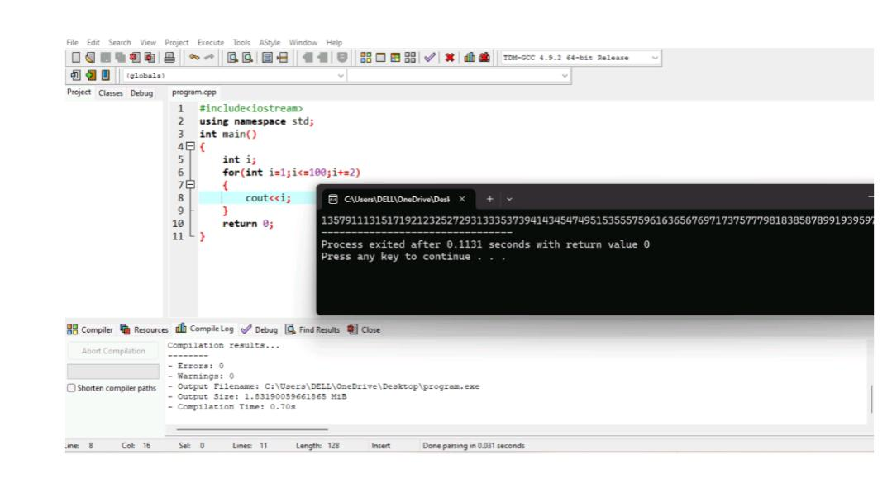

Question 2:

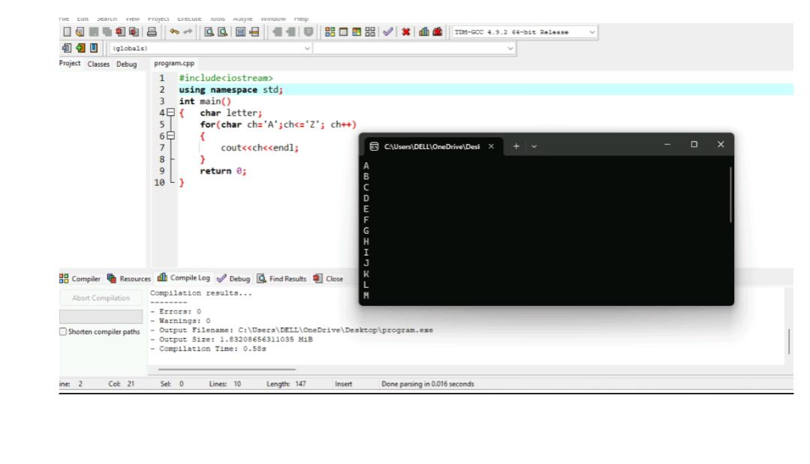

Question 3:

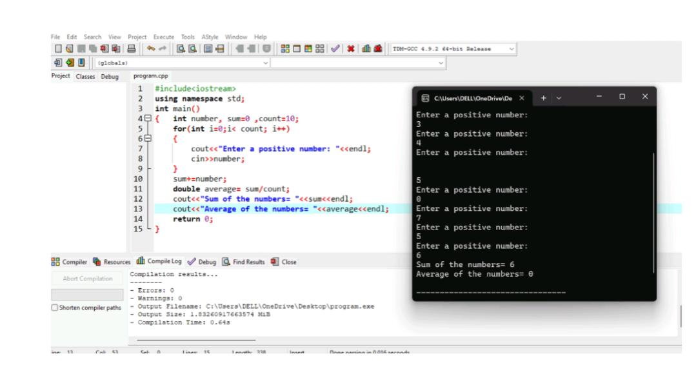

Question 4:

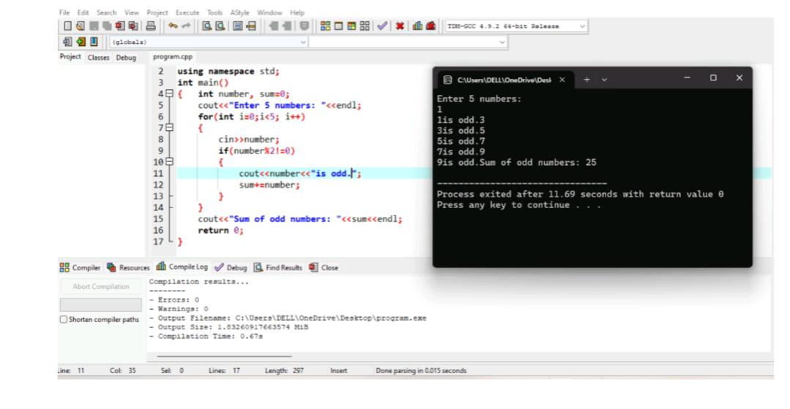

Question 5:

